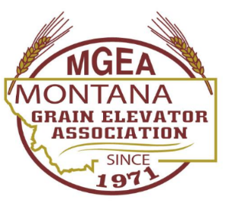
Board of Directors Meeting
Clubhouse Bar and Grill | 1411 Main St., Fort Benton, MT 59442
Thursday, September 7, 2023 - 6:00 P.M.

Jayson Hauer, President | Brad Kantorowicz, Vice-President | Derek Gibson, Treasurer
Terry Bartelt | Jarvis Frank | Michael Killen
Garrett Nygard | Justin Hager | Reed Gibson
Greg Thayer | Katelin Standley

Agenda
- Welcome and Introductions
- General Public Comment
This is the time for comment on public matters that are not on the agenda. Public matters do not include any pending legal matters or private personnel issues. Please do not attempt to address such issues at this time or you will be ruled out of order. The Board cannot enter a discussion during General Public Comment.
- Approve June Minutes
- Committee Reports
This is the time to discuss topics relevant to the said committee with potential preparation for action as described under old/new business.
  - Executive Director
    - November meeting Heritage Inn, hotel rooms Sunday night November 26. Must reserve room by October 26 or they are released.
    - Independent Contractor License
  - Convention Committee
    - Think of moderators
    - Safety seminar
  - Membership
    - Dues increase.
  - Technology
    - Website changeover
  - Transportation
  - Legislative
  - Scholarship
  - Golf
  - Governance Bylaws
- Approve Financials
  - Approve adding Micky to the Stockman Bank account as a signer including a debit card.
- Old Business
  - Approve, deny, or discuss membership dues.
- New Business
  - ED Employment
- Next Meeting – November 27th, 2023
- Adjourn

